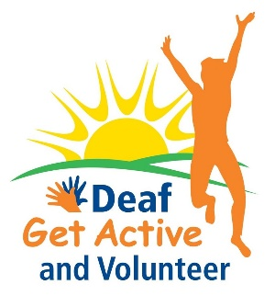
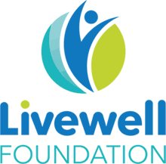

Plymouth Deaf Get Active - Welcome!!
It is great that you have signed up for our BSL Couch to 5K or Strive for Five programmes! We are here to support you.
We need to ask you a few questions before you can get going. Your name and individual answers will remain confidential to Plymouth Deaf Keep Active and Living Options Devon. We comply with all legal requirements regarding the storage and handling of data.
Your name

Telephone number
Email
Will you be doing
Couch to 5K or Strive for Five?
Will you join our Plymouth Deaf Get Active Facebook group?
This is a private Facebook group where we will share updates and information and videos for you. You can join here: ADD LINK

Yes No

If no, how would you like us to keep in touch? For example, emails, video calls

Please watch this video before starting Couch to 5 K or Strive for Five: Important Information

Please tick this box if you have watched the video:
Please tell us how often you have participated in physical activity or sport in the last 6 months? Tick one box.
Twice a week or more
Once a week
Once a fortnight
Once a month
Less than once a month
Not sure

How would you rate your physical health? Tick one box
 |  |  |  |  |  | ?
Excellent | Very good | Good | Fair | Poor | Very poor | Not sure

In general, how would you rate your mental health? Tick one box
 |  |  |  |  |  | ?
Excellent | Very good | Good | Fair | Poor | Very poor | Not sure

Thank you for your time and good luck with the Couch to 5K or
Strive for Five!

Contact us
Project email: deafgetactive@livingoptions.org
Project administrator: Katherine Last: katherine.last@livingoptions.org
Deaf Engagement Worker: Mark Cunliffe: mark.cunliffe@livingoptions.org

