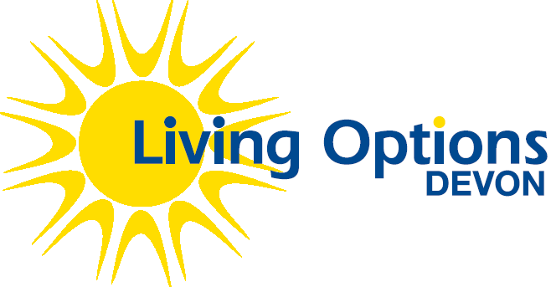
Job Description and Person Specification

Job title: Deaf Get Active & Volunteer Project Manager
Reports to: Research Impact & Performance Manager
Salary and benefits: £26,317 pro rata full time equivalent (NJC SCP 22)
Contributory Pension
Hours: 16 hours per week
Location: Cranmere Court
Period of Notice: 1 month
Contract: Fixed Term until 31/08/2022

Background/context
Living Options Devon (LOD) is a charity and a company limited by guarantee founded over 30 years ago. Our vision is of a fully informed, accessible and inclusive society in which every individual has the choice and opportunity to achieve their full potential and take part as an equal and valued citizen.

We exist to ensure people with physical and/or sensory disabilities and Deaf people, using sign language, can make an active and equal contribution in society. Specifically we:
- Encourage people to feel more informed, valued and confident to take part in society through relevant training and support;
- Enable people to identify priorities and develop user-led services;
- Engage people in effective communication with local/national service commissioners and providers; and
- Empower people to raise awareness of what society needs to do to provide equality of opportunity both locally and nationally.

We believe in a fully accessible society where all people can enjoy freedom of choice and equality of opportunity. We operate a culture of open communication, empowerment and development, where individual differences and abilities are respected and people are encouraged to achieve their full potential.

Deaf Get Active & Volunteer
The Deaf Get Active & Volunteer project works with Deaf British Sign Language (BSL) users and local sport / activity providers to improve accessibility and increase participation in sport / physical activity in the local Deaf community.

The project aims to increase participation in sport / activity in the local Deaf community through volunteer-based peer support and online resources. Alongside this, we will improve accessibility and address some of the barriers to participation through the provision of Deaf Awareness and British Sign Language training to local sports /activity providers.
Purpose of the role
To manage the delivery of Deaf Get Active & Volunteer project ensuring that the aims and objectives are achieved on time and within budget as outlined in the project plan.

Main Duties
Volunteer buddies and the Deaf community
- To oversee volunteer buddy recruitment, coordination and support, alongside the Deaf Engagement worker
- To coordinate induction, safeguarding and first aid training sessions for volunteers
- To oversee volunteer buddy activity with Deaf participants, alongside the Deaf Engagement worker (peer support, bi monthly activities, exercise classes)
- To work with the Deaf Engagement worker and volunteer buddies to organise outings for Deaf people for a variety of outdoor and indoor activities
- To organise two DGAV events, to celebrate the achievements of buddies and Deaf participants, to include group activities
- To gather feedback from volunteers and participants to support evaluation / impact measurement of the project
- To oversee the implementation of a social media plan with the aim of building our online community for local Deaf people interested in a more active lifestyle
- To oversee delivery of the Plymouth Keep Active project to be completed by September 2020.

Local sports / activity providers
- To work in partnership with Active Devon, sharing knowledge and expertise, to support the engagement of local sports / activity providers with the project and build participation in activity in the local Deaf community
- To build and maintain positive working relationship with local sports / activity providers
- To provide advice and guidance to help local sport / activity providers improve accessibility for Deaf people
- To coordinate the delivery of Deaf awareness training and BSL workshops as well as the development of online resources and BSL booklets.
- To deliver Deaf awareness training and BSL workshops
- To gather feedback from partners and activity providers to support evaluation / impact measurement of the project
Project management
- Line Manage Deaf Engagement Worker and Project Administrator to include monthly one to one meetings and regular appraisals
- To reengage the Project Steering group, recruiting new members where necessary and coordinate quarterly meetings
- Devise, create and implement operational project systems to aid in the smooth running of the project
- Generate reports to feedback to the project steering group alongside Research Impact and Performance Manager
- Report to funders as and when required with the support of the Research, Impact and Performance Manager
- Maintain and service the project’s management structures through regular project meetings
- Work with Research, Impact and Performance Manager to implement project monitoring and evaluation processes
- Develop and implement a Marketing and Communications Plan
- Work with Research, Impact and Performance Manager to ensure effective budget management

General Duties
- Act as positive role model to equality and diversity, attending meetings to represent Living Options Devon
- Attend and participate in regular staff, Project Lead and team meetings.
- Attend mandatory staff induction training and refresher courses
- Attend appropriate training courses where identified.
- Attend and participate in regular work appraisals and any other support systems as appropriate.
Attribute | Essential | Desirable
Qualifications and skills | - Degree level education or work experience equivalent
Experience | - Experience in managing and delivering projects.  - Experience of maintaining successful partnerships.  - Experience of budget management and monitoring standards  - Experience of undertaking risk assessments and managing health and safety. | - Experience of fundraising in the charity sector and familiarity with external funding sources.  - Experience of working in a sports/recreational field
Knowledge | - Knowledge of the challenges/barriers Deaf people face accessing sports  - Knowledge of HR and volunteer management good practice  - Knowledge of relevant health and safety legislation. | - Knowledge of the social model of disability.  - Knowledge of sports/recreational activities, clubs and groups across Devon
Management of people | - Experience of recruiting and working with volunteers.  - Excellent facilitation skills including the ability to encourage and support others into action. | - Experience line managing staff
Communication | - Excellent communication skills  - Confident in presenting information to wide variety of audiences via a range of media; excellent written and verbal communication skills including experience of writing reports.  - Excellent networking skills and ability to develop and manage productive partnerships and relationships.  - Experience of using a range of communication methods, including social media. | - Experience of public speaking and liaising with the media, including writing of articles and press releases.
Personal Qualities | - Self-motivated and proactive  - Ability to think laterally and creatively in order to propose innovative solutions  - Tactful, diplomatic and confident
Physical | - Able to carry out the duties of the post with reasonable adjustments where necessary.  - Ability to travel across the Devon  - Willingness to work evenings and weekends where required.
Technology / IT Skills | - Excellent use of IT including good knowledge of Microsoft Office.  - Experience of using digital/online resources. | - Knowledge of developing and maintaining websites.

