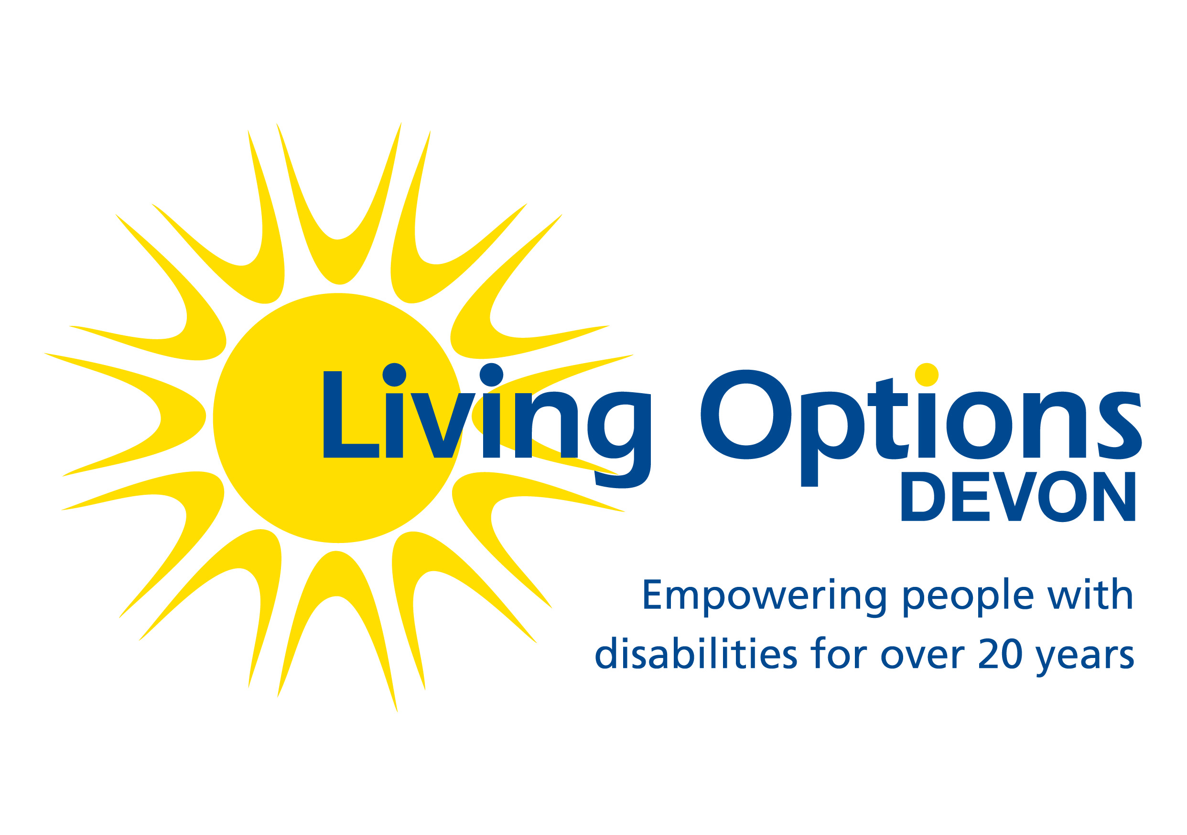

Job Description

Job title: Independent Care Act Advocate (ICAA)
Reports to: Advocacy Manager
Hours: 22.5 hrs per week
Salary: £25,481 p.a. pro rata NJC Scale 19
Location: Home-based with flexibility to cover Devon-wide remit
Contract: Permanent

NB This post is exclusively funded through the Devon County Council (DCC) Devon Advocacy Service contract to deliver advocacy services in accordance with the DCC specification. The successful applicant will need to provide two references and a satisfactory Disclosure and Barring Service check at enhanced level.

Background/context
Living Options Devon (LOD) is a charity and a company limited by guarantee founded 20 years ago. Our vision is of a fully informed, accessible and inclusive society in which every individual has the choice and opportunity to achieve their full potential and take part as an equal and valued citizen.

We exist to ensure people with disabilities and Deaf people with sign language can make an active and equal contribution in society. Specifically we:
- Encourage people to feel more informed, valued and confident to take part in society through relevant training and support;
- Enable people to identify priorities and develop user-led services;
- Engage people in effective communication with local/national service commissioners and providers; and
- Empower people to raise awareness of what society needs to do to provide equality of opportunity both locally and nationally.

We believe in a fully accessible society where all people can enjoy freedom of choice and equality of opportunity. We operate a culture of open communication, empowerment and development, where individual differences and abilities are respected and people are encouraged to achieve their full potential.

We strive to be user-led in all that we do, enabling disabled and Deaf people to influence and manage our full range of services and operations.

Advocacy Service Profile

The Devon Advocacy Consortium is commissioned by Devon County Council to provide a high- quality Care Act advocacy service across Devon and Torbay for vulnerable adults with complex health or social care needs due to physical, learning or sensory disability, deafness (for whom British Sign Language is their first or preferred language), acquired brain injury and/ or general frailty. We also provide Care Act advocacy to unpaid carers.

The aim of the Devon Advocacy Consortium (which is made up of a number of local specialist providers) is to provide a joined up advocacy service which meets the needs of vulnerable people across Devon.

The Definition of ‘Advocacy’

“Advocacy is taking action to help people say what they want, secure their rights , represent their interests and obtain services they need. Advocates and advocacy schemes work in partnership with the people they support and take their side”. (Quality Standards for Advocacy Schemes, Action for Advocacy.

Organisational Chart
Advocacy Manager

Supervising Care Act Advocate
Supervising Paid Representative

Paid Representatives

Independent Mental Capacity Act Advocates
Care Act Advocates

Job Profile

To act as an advocate for vulnerable adults with complex health or social care support needs due to physical, learning, and/or sensory disability or general frailty.

Due to the nature of this role of working in very rural areas, it is essential that the post holder is able to travel to all areas of Devon. The cost of parking and travel expenses will be met in accordance with Living Options Devon’s terms and conditions.

The successful applicant will need to provide two references. Due to the nature of the job, this post is exempt from the Rehabilitation of Offenders Act 1974. The successful applicant will be required to complete a Disclosure and Barring Service form in line with the Police Act 1997.

Key responsibilities and tasks

To actively undertake casework of the Advocacy service:
- Working directly with people with a physical, learning and/or sensory disability and/or older people and their carers, particularly those who have general frailty, are socially excluded, who have health and social care needs and/or who are unable to be helped by existing organisations;
- Empowering users to live independent lives by providing one to one support to enable them to address their problems;
- Working in partnership with the community and voluntary sectors and engaging with other services and organisations to provide a more ‘seamless’ service for older and disabled people;
- Monitoring and evaluating the service against planned outcomes and provide quarterly reports on the projects progress;
- Working within our principles of equal opportunities;
- To produce quality reports of individual advocacy casework;
- To liaise, communicate and negotiate effectively with a range of Health and Social Care personnel; and
- To attend appropriate meetings.

- To receive allocated referrals from the Advocacy Manager and to manage your case-load to meet the needs of the clients and commissioners.
- Delivering the advocacy service in accordance with all LOD policies and procedures and Advocacy Charter standards
- Follow all requirements as set out in the Devon County Council contract and other relevant specifications as requested by your line manager
- To work with the Advocacy Manager to prioritise work to meet the needs of clients and commissioners.
- To record client work appropriately to comply with the Data Protection Act and the contract specification.
- To support the Advocacy Manager in meeting the requirements for internal and external monitoring and evaluation.
- To disclose any potential conflicts of interest associated with advocacy cases to Advocacy Manager
- To keep up to date with policy and legal changes relating to advocacy services.

General duties
- To undertake an initial training and induction programme.
- To take part in supervision, team development and individual performance reviews as required.
- To attend and participate in regular Advocacy team meetings and occasional LOD staff meetings
- To actively participate in an appraisal/personal development planning process.
- To support the learning and practice of other members of the Advocacy team as appropriate.
- To perform other duties that may be required by the employer to provide effective advocacy to clients and to ensure the efficient running of the organisation

Person Specification | Essential | Desirable
Knowledge and Qualifications
Good general higher education | 
High level of literacy and numeracy | 
Good understanding of the principles of advocacy | 
Proven understanding of the needs of people with physical or sensory disabilities or older people | 
Good working knowledge of statutory and voluntary services |  | 
Ability to travel around Devon | 
Understanding of the issues around Safeguarding and confidentiality | 
Health and social care related qualification |  | 
Accredited Advocacy qualification |  | 
Knowledge of Advocacy Charter Standards |  | 
Knowledge of relevant current legislation (e.g. Care Act, MCA) | 
Computer literate with knowledge of Word, Excel, Outlook and use of internet | 
Experience
Previous advocacy experience |  | 
Experience of working with people with complex problems | 
Experience of empowering people | 
Experience of managing own caseloads and prioritising needs | 
Experience of working with health and social care |  | 
Experience of working to Advocacy Charter standards |  | 
Skills
Strong problem- solving skills | 
Excellent interpersonal and communication skills with service users, professionals and others | 
Excellent writing and reporting skills | 
Good creativity skills | 
Effective organisational skills | 
Other
Commitment to the values and policies of LOD | 
Willingness to work very occasional evenings or weekends | 
Willingness to act as a team player but motivated when working alone | 
Flexible and co-operative attitude to work routine | 
Interest in disability and deaf issues | 
Personal experience of disability or deafness |  | 

